Introduction
This document details the design specification for Blackhawk Systems’ MiniNav product.
The document is split into 3 main sections. The high level design section gives an overview of the behaviour at the application level, including suggested designs for the screen layouts, and attempts to encompass all of the required functionality in its description.
The low level design section is a refinement of the high level design. It defines algorithms and suggested implementations, including the definition of global variables that assist in the communication of state and data between the modules of the application. It is not necessary for the coding phase to strictly follow the function heirarchy, variables or algorithms discussed in this section, but the resultant code should be structured very similarly to the low-level design in order for it to be of any value as an aid to understanding the software.
The appendices are repositories for information that is pertinent to the design of MiniNav but does not fit neatly into the high or low level design sections. Much of the data in the appendices will be fed into this document from the coding phase, to explain some of the more complex algorithms or data structures that MiniNav uses.

High Level Design

Interface Overview
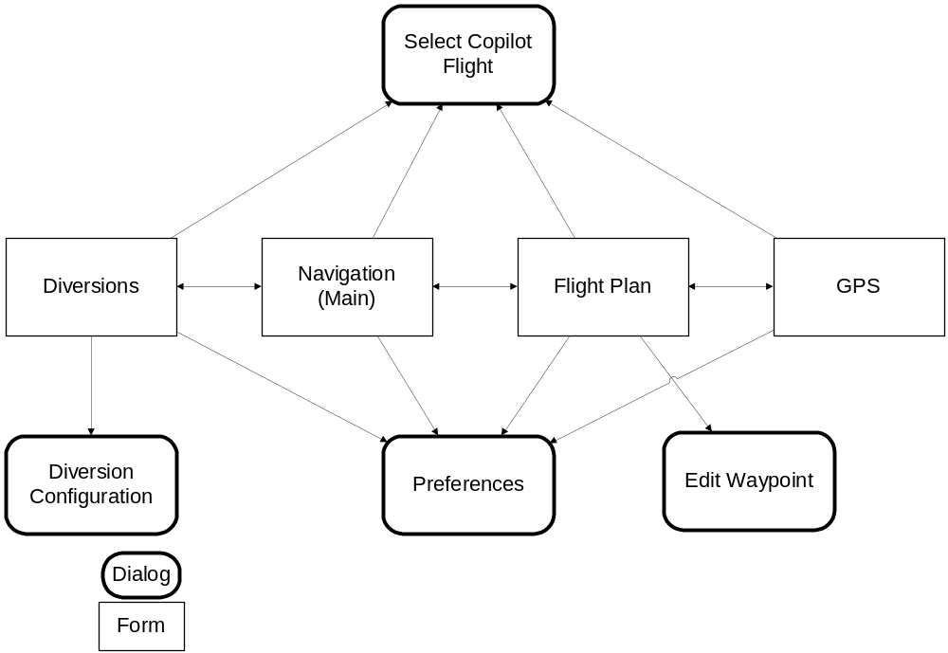The following diagram shows the ways in which the user navigates the MiniNav screens.
.
Notes:
- The user can press the Notepad and Task application buttons to move forwards and backwards between the main screens.
- The user can press the Datebook application button to go to the Edit Waypoint Form. If the user presses the date button with a valid GPS position fix, then MiniNav creates a new waypoint and opens the Edit Waypoint dialog. The new waypoint is named ‘WPT-N’ where N is the waypoint number.
- The user can press the Contacts application button to goto the Diversion Display when a diversion is already activated.

Application Level Behaviour

Startup
MiniNav detects any previous MiniNav version preferences and databases and upgrades them to the new format for the current release (if applicable).
If MiniNav detects a launch from CoPilot (signalled via a launch code), then it loads the currently active CoPilot flight plan (determined by reading the CoPilot preferences). If this plan is not valid, then MiniNav displays the Select CoPilot Flight dialog box.
Otherwise, if MiniNav is launched with the CoPilot Integration function active, then it displays the Select CoPilot flight option.
MiniNav checks that it is registered at every start up – if not, it displays a nagging dialog.
MiniNav displays a standard disclaimer at every launch, to warn the user not to rely on GPS as a primary navigation aid.

Monitoring GPS Messages
MiniNav processes GPS messages at least once per second while any of the four main screens is being displayed (but not during dialog/alert displays)

Monitoring Keypresses
MiniNav processes the following hard-key events while any of the four main forms are being displayed:
- Hard key 1 (Datebook)- Waypoint-from-location. Opens the new waypoint window, or if already open selects the OK button.
- Hard key 2 (Contacts) – Divert. Action depends on current display, current diversion state (ds) on/off, and keypress duration (t):
  - ds=on, GPS, Flight or Navigation Display: goto diversion Display
  - ds=on, Diversion Display. Ignore
  - ds=off, t<1s Navigation and FlightDisplay : MiniNav sets up a direct-to diversion.
  - ds=off, t<1s GPS Display: MiniNav opens the Diversion Display
  - ds=off, t<1s Diversion Display: MiniNav sets up a Goto diversion.
  - ds=any, t≥1s on ANY display: MiniNav sets up an emergency diversion.
- Hard key 3 (Tasks) – Backwards. MiniNav moves to previous display in sequence.
- Hard key 4 (Notes) – Forwards. MiniNav moves to next display in sequence.
Notes on Hard key 2 (Contacts/Divert):
The requirement is for the user to depress the key for >1s to activate the emergency diversion feature. During this time, the display indicates that the key is depressed and that the emergency feature is about to be activated. If the user releases the key before the 1s limit, then the keypress is dealt with as a <1s keypress (see above).

Task scheduling
MiniNav must perform the following tasks to a schedule regardless of the active display:
- GPS input processing (1 second intervals, when GPS is enabled)
- Form update (once per second, preferably after a GPS update)
- Background database scanning (200ms, as often as possible).
The task-scheduling algorithm is combined with the PalmOS event loop code to ensure that the above tasks occur in a timely manner, without sacrificing the responsiveness of the PDA or MiniNav itself.

Background Database Scanning (Diversions)
MiniNav keeps an up-to-date list of the waypoints that are nearest to the current GPS position; this list is used in the Diversion Display. The waypoints are determined by examining the CoPilot System and User databases.
Scanning a usefully-sized CoPilot database in a single pass is impractical, so MiniNav is designed to background scan portions of the database at a time.
The number of records that MiniNav will scan at once will vary according to the speed of the device upon which it is running, but in order to maintain device response and MiniNav’s performance it is estimated that MiniNav will only be allowed to scan the database for 200ms at a time. With this maximum limit, and depending on other tasks, the scan may be allowed a total of up to 800ms in any one second. Code optmisation and efficient algorithms for scanning are vital, especially for the slower PalmOS devices.

Forms and Dialogs

Main Form
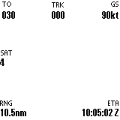
The heading indicator is not shown in this diagram.
The Main Form has a menu with these options:
- Diversions…
- Flight Plan…
- GPS…
- CoPilot Flight…
- Preferences…
- Scanning…
- About
The menu must be activated using the Menu button on the silk-screen – there is no space on the screen to have a permanent menu bar.
The form updates once per second. During the update all data is read from the GPS and used to update the data in the readouts and the heading indicator. GPS data is read every second to prevent the serial buffer from overflowing and causing serial errors.
The data displayed on screen is as follows (clockwise, starting from top left):
- Bearing to or from the selected waypoint from the current position in degrees, and a to/from flag indicating current display mode. Waypoint range is displayed below, and the compass bearing from (always from) the waypoint
Note: The numerical bearings may be displayed in degrees true or magnetic (FROM uses the magnetic variation of the waypoint, TO uses local magnetic variation).
- Ground track in degrees true or magnetic. Ground speed in selected units. XTRK error is displayed below.
- Current altitude in selected height units (or “2-D ONLY” if the GPS is only providing a 2-d position fix).
- Waypoint ID.
- ETA: time of arrival at the current waypoint;
ETE: time to run to the current waypoint;
LOC: current local time;
UTC: current time in UTC.
- SAT: number of satellites in use.
Navigation data presented on the screen (bearings, ranges and ETAs) is determined using great circle formulae.
The current waypoint Id is shown in the centre below the heading disc. When a new waypoint is selected the new Id is shown in the centre of the display for a few seconds.
If there is no GPS position fix then the Heading Indicator is hidden from view and MiniNav displays “WARN: NO POSITION FIX” in large bold font across the centre of the form. In addition, if the GPS unit has not sent a message within a set time period MiniNav displays “WARN: GPS NOT DETECTED” below the POSITION FIX message.
The up & down hard scroll buttons control the selected waypoint.
If the ETE to the current waypoint is greater than 24 hours, then the ETE and ETA readouts show “--:--:--”.

Heading Indicator
The heading indicator displays three items of data: the current heading, the current bearing to that waypoint and the off-track error.
The current heading is displayed by the rotation of a circular disc that is numbered with tens of degrees (e.g. 12 for 120 degrees) every 30 degrees, and the cardinal points of a compass (e.g. N instead of 00, S instead of 18). The current heading is read from the top of the disc.
A rotating pointer overlaid across the heading disc shows the bearing to the current waypoint. The pointer has a detachable centre section which drifts left or right of the rest of the pointer to indicate the off-track error. Dots to the left and right of the centre of the pointer indicate the degree of off-track error, each dot represents ½ a unit. The indicator displays a maximum of two units of off-track error in either direction; if error is greater than two units then the dots are not drawn.

GPS Form
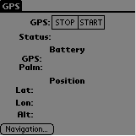
The Stop/Start pushbuttons control the communications to the GPS unit connected to the serial port of the device. The current selection is highlighted (not shown here).
The GPS Form has a menu with the following options:
- Diversions…
- Navigation…
- Flight Plan
- CoPilot Flight…
- Preferences …
- Scanning…
- About
The stop/start pushbuttons control the state of the communications to the GPS unit.
The form opens the serial port when the start button is selected and henceforth reads data from the GPS once every second.
The form keeps the status field updated with one of the following values:
- Stopped (the GPS has been stopped by the user).
- Started (the GPS has been started, but no data yet).
- Acquiring Fix (GPS satellite signal data being received, no fix yet)
- 2-d Fix, N satellites (2 dimensional position fix)
- 3-d Fix, N satellites (3 dimensional position fix)
‘N’ is the number of satellites used in the fix.
MiniNav displays a heartbeat symbol after the status to give a real-time indication that GPS messages are being received – the heartbeat stops pulsing immediately when GPS messages stop coming.
The form keeps the position fields updated with the data from the GPS when the status is 4 or 5. Otherwise the lat and lon fields are blank. Palm battery state is always displayed. GPS battery status is updated as available: currently only the PMGNST message is supported.
The form closes the serial port when the stop button is selected.
The form returns control to the Main form when the Return button is selected.

Flight Plan Form
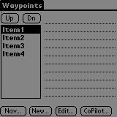
This form activates when MiniNav launches.
This form shows a list of waypoints in the left hand list box (a maximum of 8 waypoints will be available if the user has not entered a valid registration code - MiniNav disables the “New…” button if 8 waypoints have been added). The current waypoint is highlighted in the list, and the notes of the current waypoint display in the right-hand text area. There is a scroll bar on the right hand side of the text area.
The “Nav…” button activates the Navigation form.
MiniNav displays the “CoPilot” button only if CoPilot launched MiniNav. Selecting the CoPilot button launches CoPilot.
The Flight Plan Form has a menu with the following options:
- Diversions…
- Navigation…
- GPS…
- CoPilot Flight…
- Preferences…
- Scanning…
- Reverse…
- Delete All…
- About
The form displays the waypoint Ids for the waypoints that the user has added.
The Edit Waypoint Dialog opens if the Edit… or New… buttons are pushed. MiniNav creates a new waypoint when the New… button is selected, and then displays the Edit Waypoint Dialog. The Up & Dn command buttons move the current waypoint up or down in the list of waypoints.
The Reverse… menu option reverses the order of the waypoints.
The Delete All… menu option displays a confirmation warning and then deletes all of the waypoints. It displays a warning that the operation is not valid when using a CoPilot flight.
The hard-scroll buttons cause the current waypoint to be changed.
The form allows GPS messages to process at least once a second if the GPS has been started.

Edit Waypoint Dialog
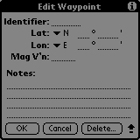
Latitude and Longitude minutes are limited to 2 decimal places; this gives an accuracy of at least 60 feet. Magnetic Variation (Mag V’n) is a floating-point number that is negative for east, positive for west.
The edit dialog opens with the data for the waypoint to be edited filled into the fields.
If the waypoint to edit is the only waypoint, then the Delete Button is disabled, so that MiniNav always has at least one waypoint.
If the waypoint is empty then all fields will be empty, except that if the GPS is running and providing a position fix then the current GPS coordinates will be loaded into the Lat/Lon and MagV’n fields.
Selecting OK or pressing the datebook key causes the fields to be validated according to the following:
- The waypoint Id is any combination of up to 6 alphanumeric characters.
- The waypoint Id is unique.
- Latitude values are range checked:
0 ≤ d ≤ 90
0.0 ≤ m < 60.00
- Longitude values are range checked:
0 ≤ d ≤ 180
0.0 ≤ m < 60.00
- The description field is any text string up to 4 lines in length.
- The Magnetic Variation value is checked:
-180 ≤ mv ≤ 180
When the user selects OK and the data in the dialog is valid then the data for the waypoint is updated and the form closes (returning control to the Waypoint List form). If the data is invalid, the dialog will prompt the user to correct the error(s) via an alert box.
Selecting Cancel causes the changes to be aborted and the form to close. If the waypoint is a new waypoint (created by selecting “New…” on the Waypoint List form) then the newly created waypoint is deleted.
Selecting Delete displays the confirmation dialog. If the user selects OK on the dialog then the waypoint data is cleared and the Edit Waypoint Dialog is closed. If the user selects cancel then the dialog remains open.
The dialog allows GPS messages to process at least once a second if the GPS has been started. The dialog does not show changes in the status of the GPS fix.
GPS messages continue to be processed whilst this form is active.

Diversion Display
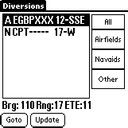
If the GPS is started, then this screen shows a list of the nearest waypoints to the current GPS position, sorted by range. Otherwise the list is empty and all the controls are disabled.
The waypoints included in the list are selected from the CoPilot System and User databases, according to the settings chosen in the Diversion Configuration Dialog. Each line in the list contains an entry for a single waypoint with the following data:
- Icon representing the waypoint type: Airfield(usable), Airfield(unusable), Navaid or Blank for other)
- First characters of waypoint ID.
- First characters of the waypoint description
- Range to the waypoint (in user configured units)
The currently highlighted item in the list is used to derive the data displayed in the line below the list box. The data includes Bearing to (Brg), Range (Rng, in user preferred units) and ETE (minutes). This data is kept up to date in real time.
The push buttons on the right of the display control what types of waypoints are shown. “Navaids” includes waypoints of type VOR. VOR/DME, TACAN and NDB. “Other” includes waypoints that are not of type Airport or of type Navaid.
The Goto button causes the currently highlighted waypoint to become the Goto waypoint. The Divert button (Contacts) may also be used on this screen for the same task. The current position and the goto waypoint’s position are inserted into the flight plan before the current selected waypoint, and the Goto waypoint becomes the current waypoint.
Whenever a diversion is active, the Goto button is renamed to the Resume button. When the Resume button is pressed, diversion to the Goto waypoint is cancelled. The current waypoint becomes the waypoint following the Goto waypoint’s position in the flight plan.
The Up & Down hard keys move the waypoint selection accordingly. If a waypoint is not selected, then the list is scrolled.
The Diversion Display has a menu with the following options:
- Navigation…
- Flight Plan…
- GPS…
- CoPilot Flight…
- Preferences…
- Scanning…
- About
The Configure menu option opens the Diversion Configuration Dialog.

Diversion Configuration Dialog
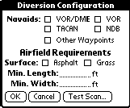
This dialog box allows the user to specify the sorts of waypoints that will be listed in the Diversion Display.
The four Navaid types correspond to Navigation aid types that can be found in the CoPilot database. When selected, the corresponding navaid type is included in the database scan. The Other Waypoints type corresponds to all waypoints whose type cannot be determined, or is not recognised.
The airfield requirements section allows the user to specify the runway surface(s) and the minimum runway width & length that are acceptable for use by his aircraft in the event of an emergency diversion being activated.
The OK button validates and saves the configuration, the Cancel button discards any changes.
The Test Scan button causes MiniNav to perform a scan of the CoPilot databases using the settings in the current dialog, and to report the result of the scan to the user. This gives the user feedback as to how long MiniNav will take to cycle through the waypoint databases. MiniNav shows a progress indicator during the scan, and a cancel button that allows the scan to be stopped.

Select CoPilot Flight Dialog
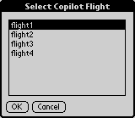
This dialog allows the user to change the currently loaded CoPilot flight plan.

Preferences Dialog
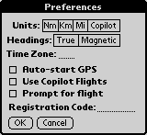
This dialog allows the user to configure MiniNav with their preferences, and also allows the user to enter a registration code. The options are:
- Units of measure:
Nm = speed in kts, height in feet, distance in nm
Mi = speed in mph, height in feet, distance in miles
Km = speed in kph, height in metres, distance in km
CoPilot = use settings from CoPilot preferences
- Headings: True or Magnetic
- Time Zone: -11 to +12 hours
- Auto-start GPS: if selected, GPS starts on application launch
- CoPilot Integration: if selected, enables interface to CoPilot
The “CoPilot Integration” checkbox is only enabled if the CoPilot application is present on the Palm device and the application is registered. The “CoPilot units” pushbutton are enabled or disabled according the availability of CoPilot.
This form also allows the user to enter a valid registration code that unlocks the software and allows access to the off-track error indicator on the Heading Indicator, the additional 8 waypoints (for a maximum of 16 waypoints), and the “CoPilot Integration” checkbox.
If the user selects “OK” then the preference settings are updated. If the Registration Code” field has been changed then the registration code is also checked for authenticity, causing either the Registration Succeeded or Registration Failed alert to display before returning to the Main Form or Preferences Dialog
If the user selects “Cancel” the form closes and returns to the Main Form.

Alerts and Warnings

ROM Incompatible

Disclaimer

About Box

MathLib Required

Serial Port

Waypoint Latitude Input Error

Waypoint Longitude Input Error

Waypoint ID Error

Waypoint Magnetic Variation Error

Time Zone Error

Registration Succeeded Information
This alert tells the user: “Thank you for registering!”.
A single “OK” button allows the user to continue.

Registration Failed
This alert tells the user: “The registration code you have entered is invalid. If you believe the code is valid please email support@ blackhawksystems.co.uk”.
A single “Back…” button returns the user to the Preferences Form.

Registration Nag
This screen is displayed when MiniNav is launched without a valid registration code. It tells the user “This version of MiniNav has not been registered. You will not have access to full functionality until this product is registered. Please register at handango.com or palmgear.com”.
A single “Continue” button allows the user to continue.
There are two versions of this alert, one for PalmGear and one for Handango.

CoPilot Not Found
This alert displays on application start-up if the “CoPilot Integration” option is selected and MiniNav cannot locate CoPilot or its database files, or a valid flight within the database. In this situation, the Use CoPilot option is disabled.

Enable CoPilot
This alert is displayed when the user selects the “CoPilot Flight” option from the main menu and CoPilot flights are not enabled.

Generic Warning
This alert box is displayed for general warnings.

Confirm Waypoint Delete
This alert is shown when the user selects the “Delete…” button on the Edit Waypoint dialog.

Database Scan Results
This alert is shown after the user has selected a Test Scan from the Diversion Configuration Dialog. It reports the time taken to scan the CoPilot databases, and a predicated background scan time.

Delete All Waypoints
A confirmation dialog shown when the user has selected Delete All… from the Flight Plan menu.

Not Allowed to Delete
This dialog is shown when the user tries to Delete All… waypoints when using a CoPilot flight.

Low Level Design

Software Architecture
<Name> represents a global variable
|Name| represents a module variable.

PilotMain
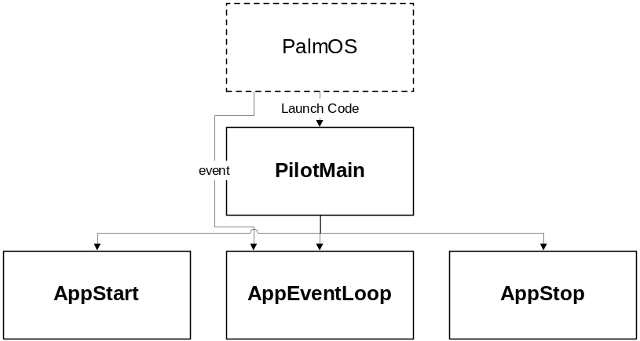
PalmOS sends a launch code to the PilotMain function of MiniNav. PilotMain calls AppStart and AppEventLoop in response to a sysAppLaunchCmdNormalLaunch code. AppEventLoop exits when it receives an appStopEvent event, then PilotMain calls AppStop before ending the application.

AppStart
Inputs: Preferences Database
Outputs: <Number of Waypoints> <Preferences>
<Local Time Zone> <Valid Registration>
Check that MathLib exists and load it.
Open the default Waypoint data database; if it doesn’t exist then the database must be created with an initial record.
If old application preferences exist, upgrade them to new version and update the records in the waypoint database to add the Magnetic Variation value. If preferences don’t exist initialise <Preferences> with defaults. Otherwise, read <Preferences> from the PalmOS preferences database.
For version 2.0/2.1 to version 2.11 upgrade, the waypoint database format has changed as follows:
- Magnetic variation is changed from double to float
- radE removed, radW replaced. Therefore sign has changed.
- Removed Lat/Lon string storage fields.
Check that CoPilot and its databases are installed and set <CoPilot Installed>. If not, and <Preferences>.useCoPilotFlights then display the CoPilot Not Found alert and reset the .useCoPilotFlights and .promptForFlight options.
Setup <Display Units> according to <Preferences>.units – if CoPilot units, then access CoPilot’s preferences to determine the values.
Validate the registration code, and set value of <Valid Registration> accordingly.
Display the GPS Warning/disclaimer alert, and if ! <ValidRegistration> display the Registration Nag screen.
If CoPilot launched MiniNav, determine the active CoPilot flight and use it if it is valid, otherwise:
If <Preferences>.useCoPilotFlights then
Show Select CoPilot Flight dialog, and import the data
Open imported database
Setup ImportedDatabaseId
End if
Else
Open default waypoint database
End if

Initialise the heading indicator.
If <Preferences>.autoStartGPS then start the GPS.

AppStop
Inputs: <Preferences>
Outputs: Preferences Database
Store <Preferences> in the PalmOS preferences database, and close the waypoint database. Call CloseDB to clean up any imported databases, and close the default DB.

AppEventLoop
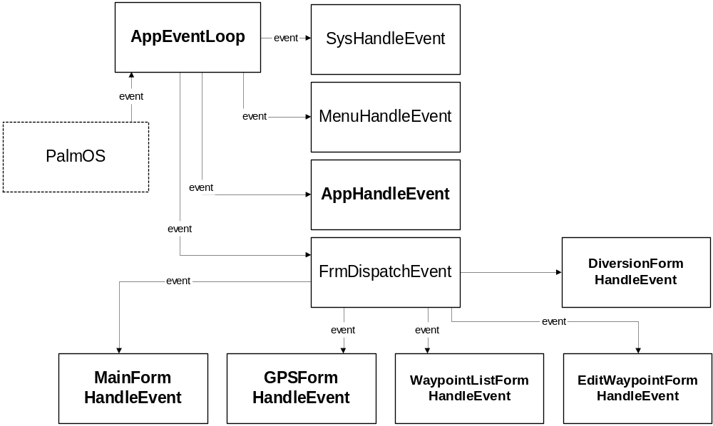
The PalmOS sends events to the event queue that is read by the main application function AppEventLoop. AppEventLoop passes the event in turn to each of the following functions until one of them indicates that it has processed the event by returning “True”:
- SysHandleEvent (system call)
- MenuHandleEvent (system call)
- AppHandleEvent (application specific)
- FrmDispatchEvent (system call)
Note: SysHandleEvent handles things such as the hard-buttons and silk-screen buttons. MenuHandleEvent handles the drop-down menus for a form. AppHandleEvent contains user written code that responds to frmLoadEvent events by loading the appropriate form. FrmDispatchEvent calls the form’s custom coded event handler before calling FrmHandleEvent to provide standard form functionality.
MiniNav has a task scheduler algorithm used whenever the GPS is active, the code for which is in AppEventLoop, and it implements the following behaviour:
MiniNav marks the start of the second. While time is left in the second, it loops as follows:
- Poll the event queue, dispatching all events.
- If not already done this second, poll the GPS, and dispatch a nilEvent to the active form (the nilEvent allows GPS-fed forms to update using fresh data).
- Determine how much of the second is left, and allocate that to the database scanning task. The DB scan task is governed by a minimum and maximum time limit. The minimum specifies the time in which it is allowed to run uninterrupted (suggest 250ms); the maximum is the time limit at which it must terminate (up to the limit of the end of the second). Between the minimum and maximum limits the DB scan task should return immediately if an event is detected in the PalmOS event queue (suggest a 125ms resolution for checking for an event).
If the GPS is not active, then the behaviour is different:
MiniNav waits forever for an event (normal PalmOS behaviour).
There is scope for tuning this scheduling algorithm, and experimentation is recommended to achieve the best balance between GPS updates, system response, and database scan performance.

AppHandleEvent
Inputs: event – the event <Diversion State> <Current Display>
Outputs: None, <New Waypoint> <Current Display>
This function handles all of MiniNav frmLoadEvents.
MiniNav intercepts all of the application key presses (vchrHard1 to vchrHard4) The key presses cause the following behaviour:
- Hard key 1 (Datebook)- Waypoint-from-location. Opens the Edit Waypoint form with <New Waypoint> set true, or if already open selects the OK button.
- Hard key 2 (Contacts) – Divert. Action depends on <Current Display>, <Diversion State> (ds) on/off, and keypress duration (t):
  - ds=on, GPS, Flight or Navigation Display: goto diversion Display
  - ds=on, Diversion Display. Ignore
  - ds=off, t<1s Navigation and FlightDisplay : MiniNav sets up a direct-to diversion.
  - ds=off, t<1s GPS Display: MiniNav opens the Diversion Display
  - ds=off, t<1s Diversion Display: MiniNav sets up a Goto diversion.
  - ds=any, t≥1s on ANY display: MiniNav sets up an emergency diversion.
- Hard key 3 (Tasks) – Backwards. MiniNav moves to previous display in sequence.
- Hard key 4 (Notes) – Forwards. MiniNav moves to next display in sequence.
Notes on Hard key 2 (Contacts/Divert):
The user must depress the key for >1s to activate the emergency diversion feature. During this time, MiniNav shows a window in the centre of the display that indicates that the key is depressed and that the emergency feature is about to be activated. If the user releases the key before the 1s limit, then the window is removed and the keypress is dealt with as a <1s keypress (see above).

MainFormHandleEvent
MainFormHandleEvent processes the incoming event from FrmDispatchEvent by calling one of the following functions.
- MainFormInit (frmOpenEvent)
- UpdateDisplay (nilEvent)
- MainFormDeInit (frmCloseEvent)
- HandleMenuEvent (menuEvent)
- HandleKeyEvent (keyDownEvent)
UpdateDisplay is only called if |Defer Update| is false, otherwise MiniNav checks |Defer Update Time| to see if it can clear the |Defer Update| flag (this allows the new waypoint Id to display briefly in the centre of the screen).

MainFormInit
Inputs: FormID, <Current Waypoint>
Outputs: <Current Waypoint>, |Waypoint Record|, |CrsAB|,
|Display Units|
All gadgets initialised.
Heading indicator initialised.
Initialise the readouts.
Retrieve the |Waypoint Record| for <Current Waypoint> from the Waypoint database. If the Current Waypoint is deleted, update Current Waypoint/Waypoint Record to use the first waypoint.
Set up the <Display Units> structure.
N.B. This routine does not draw anything on the form.

UpdateDisplay
Inputs: <GPS Data>, |Waypoint Record|, <Local Time Zone>,
<Valid Registration>, |CrsAB|, |Display Units|
Outputs: None.
Calculate new data for the displays based on updated GPS data and |Waypoint Record|.
Update the data in the readouts with the current calculated data, taking into account the unit settings from |Display Units|.
If <Valid Registration> is false, then set the course deviation indicator to show no error otherwise calculate off-course error using |CrsAB|.
Update the heading indicator (and display), or display the warning messages “NO POSITION FIX” and “** GPS INPUT LOST **” as appropriate.

Great Circle Formulae
The routine uses great circule formulae to calculate distance and bearing between two points. The following algorithm is used, where (lat1,lon1) is point 1 and (lat2, lon2) is point 2 (values expressed in radians – North and West are positive for these formulae). “tc” is True Course, “d” is distance.
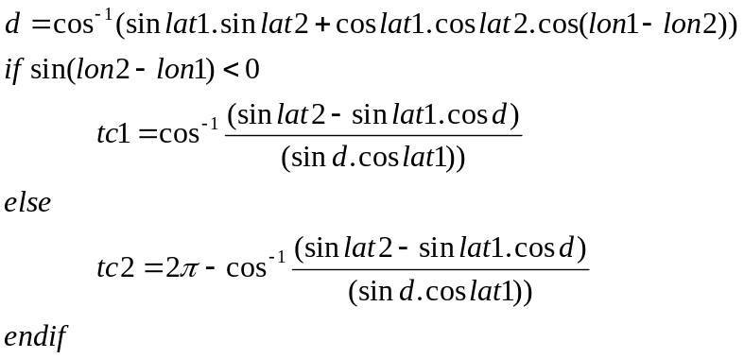

Off Track Error
Off track error is the shortest distance in nautical miles from the current position to the course between two points. The two points are the current waypoint (B) and the previous waypoint (A). If the current waypoint is the first, then off-track error is set to 0.
where d = distance from present position to destination (in radians), crsBD is course from destination to present position and crsBA is course from destination to start of leg.

MainFormDeInit
Inputs: None.
Outputs: None
This routine does nothing.

HandleMenuEvent
Inputs: menuEvent – the event
Outputs: None
Open the GPS Form, the Waypoint List form, the Preferences form, the Select CoPilot Route Form or the about box according to the menu item selected by the user.
If CoPilot Flight menu selected and !<Preferences>.useCoPilotFlights, show Disable CoPilot Alert.

HandleKeyEvent
Inputs: keyEvent – the event
<Current Waypoint>, |Waypoint Record|, <Number of Waypoints>
Outputs: <Current Waypoint>, |Waypoint Record|, |CrsAB|,
|Defer Update|, |Defer Update Time|
If the user has pressed the hard scroll up button, set Current Waypoint to the previous waypoint.
If the user has pressed the hard scroll down button, set the Current Waypoint to the next waypoint.
In either case, set Waypoint Record to the new Current Waypoint.
If the waypoint has been changed, draw the new waypoint Id in the centre of the screen, set |Defer Update Time|=Current ticks+X, set |Defer Update| true.
If the waypoint is not the first in the database, calculate new |CrsAB| value between previous and current waypoint.

GPSFormHandleEvent

GPSFormHandleEvent processes the incoming event from FrmDispatchEvent by calling one of the following functions.
- GPSFormInit (frmOpenEvent)
- UpdateDisplay (nilEvent)
- GPSFormDeInit (frmCloseEvent)
- HandleMenuEvent (menuEvent)
- HandleCtlSelectEvent (ctlSelectEvent)

GPSFormInit
Inputs: FormId, <GPS State>, <GPS Data>
Outputs: None
Initialise the state of the stop/start pushbuttons according to current GPS state.
Initialise the status indicator to Started or Stopped.

UpdateDisplay
Inputs: <GPS Data>
Outputs: Updates status and lat/lon fields
Update the status indicator, the input indicator, the Lat/Lon indications, the altitude indicator and the battery status displays. If GPS input is received, flash the heartbeat indicator.

GPSFormDeInit

HandleCtlSelectEvent
Inputs: ctlSelectEvent – the event itself.
Outputs: <GPS Status> <Local Time Zone>
Switch (control Id)
Case StopButton:
Stop the GPS comms. Set Status = Stopped, blank Lat/Lon
Case StartButton:
Start the GPS comms. Set Status = Started
Case NavigateButton:
Close the form (return to MainForm)

End Switch

WaypointListFormHandleEvent

WaypointListFormHandleEvent processes the incoming event from FrmDispatchEvent by calling one of the following functions.
- WaypointListFormInit (frmOpenEvent)
- WaypointListFormDeInit (frmCloseEvent)
- HandleMenuEvent (menuEvent)
- HandleKeyEvent (keyDownEvent)
- HandleLstSelectEvent (lstSelectEvent)
- HandleCtlSelectEvent (ctlSelectEvent)

WaypointListFormInit
Inputs: <Number of Waypoints>, <Valid Registration>, <Preferences>,
<Current Waypoint>
Outputs: None
Set the number of items in the list. Set the waypoint list drawing callback function. Make sure that the <Current Waypoint> item of the list visible.
Set the text of the waypoint notes field.
If <CoPilot Launched>, enable the CoPilot command button.
If <Preferences>.useCoPilotFlights then disable the “New…” button.

WaypointListFormDeInit
No actions.

HandleLstSelectEvent
Inputs: lstSelectEvent – the event
<Current Waypoint>, <Number of Waypoints>
Outputs: <Current Waypoint>
Update <Current Waypoint> with selected list item. Update waypoint notes field with notes from new current waypoint.

HandleKeyEvent
Inputs: keyEvent – the event
<Current Waypoint>, <Number of Waypoints>
Outputs: <Current Waypoint>
If the user has pressed the hard scroll up button, set Current Waypoint to the previous waypoint.
If the user has pressed the hard scroll down button, set the Current Waypoint to the next waypoint.
Update the currently visible list item. Update the waypoint notes display with new waypoint notes.

HandleMenuEvent
Use the common menu event handler. Additionally, if the Reverse option is invoked then reverse the order of waypoint records in the database.
If the Delete All… option is selected, and not using a CoPilot flight then show the delete confirmation dialog and then delete all the waypoints. If a CoPilot is being used, the show the warning that the operation is prohibited.

HandleCtlSelectEvent
Inputs: ctlSelectEvent – the event itself
<Current Waypoint>
Outputs: <Waypoint To Edit>, <Number of Waypoints>, <New Waypoint>,
<Current Waypoint>
If “New…” button is pressed Then
Set <New Waypoint> = true
Goto Edit Waypoint Dialog
End If
If Up or Dn pressed, then
Move the <Current Waypoint> up or down in the database accordingly
Update <Current Waypoint> (move it up or down)
End if
If the Nav.. button is selected, then go to Navigation screen
If the CoPilot button is pressed, launch CoPilot.

EditWaypointFormHandleEvent

EditWaypointFormHandleEvent processes the incoming event from FrmDispatchEvent by calling one of the following functions.
- EditWaypointFormInit (frmOpenEvent)
- EditWaypointFormDeInit (frmCloseEvent)
- HandleCtlSelectEvent (ctlSelectEvent)

EditWaypointFormInit
Inputs: FormID
<Waypoint To Edit>, <New Waypoint>, <GPS Data>
Outputs: Modified fields on form
Initialise the fields on the form with the values from the selected waypoint in Waypoint To Edit. If the selected waypoint is empty, then the fields are initialised to blanks.
If <Number Of Waypoints> == 1 Then disable the “Delete…” button.
If the GPS is giving a position fix and <New Waypoint>, then set the Lat/Lon and Magnetic Variation fields from <GPS Data>.

EditWaypointFormDeInit
Inputs:
Outputs:
Nothing

HandleCtlSelectEvent
Inputs: ctlSelectEvent – the event itself
Outputs: <Waypoint Data> <Number of Waypoints> <New Waypoint>
Switch ButtonId
Case OK Button:
If ValidateInputs then
update Waypoint Data with form data
close form
Unlock the database record
return to Waypoint List Form
else
show appropriate error dialog
end if
Case Cancel Button:
if <New Waypoint> then
Add new waypoint
end if
close the form
return to Waypoint List Form
Case DeleteButton:
display confirmation dialog
If OK selected then
Delete record
return to Waypoint List Form
end if
End Switch

DiversionFormHandleEvent
DiversionFormHandleEvent processes the incoming event from FrmDispatchEvent by calling one of the following functions.
- DiversionFormInit (frmOpenEvent)
- HandleUpdateEvent (nilEvent)
- MainFormDeInit (frmCloseEvent)
- HandleMenuEvent (menuEvent)
- HandleKeyEvent (keyDownEvent)
- HandleLstSelectEvent (lstSelectEvent)
- HandleCtlSelectEvent (ctlSelectEvent)

DiversionFormInit
Inputs: <GPS State> <Diversion State> <Nearest Waypoints> <GPS Data>
|Highlighted Divert Waypoint| |Diversion Display Filter|
Outputs:
If <GPS State> is false, then disable the push button controls, and the Goto & Update buttons. Otherwise:
Set the waypoint listbox display callback function and the current display filter pushbutton setting according to |Diversion Display Filter|. Set the selected list item in the waypoint list to |Highlighted Divert Waypoint|.
If <Diversion State> is true then rename the Goto button to Resume.
Set the value for the status line, using |Highlighted Divert Waypoint| to index into the <Nearest Waypoints> array, and <GPS Data> to calculate the bearing, range and ETE values.

HandleUpdateEvent
Inputs: <GPS State> <Nearest Waypoints> |Update Cycle|
|Highlighted Divert Waypoint|
Outputs:
If <GPS State> is false, return immediately.
Use <GPS Data> to update status line for |Highlighted Divert Waypoint|.
Check the entries in <Nearest Waypoints> that correspond to the visible items in the waypoint list; if any have changed then redraw the list entries that have changed.

DiversionFormDeInit

HandleCtlSelectEvent
Inputs: <Diversion State> <Nearest Waypoints> <GPS Data> <Current Waypoint>
|Highlighted Divert Waypoint|
Outputs: <Current Waypoint> <Diversion State> <Waypoint Data>
|Diversion Display Filter|
Goto Button
If <Diversion State> is false then
insert current position <GPS Data> and
<Nearest Waypoints>[Highlighted Divert Waypoint] into <Waypoint Data> before <Current Waypoint>.
Increment <Current Waypoint> so it points to diversion waypoint.
Set <Diversion State> to true.
Go to the Navigation Display.
else if <Diversion State> is true then
if <Current Waypoint> is one of the diversion waypoints then
Set <Current Waypoint> to waypoint after diversion waypoints.
end if
remove the diversion waypoints from <Waypoint Data>.
Decrement <Current Waypoint>
Reset label of Goto button to “Goto”
end if
Display Filter Pushbuttons
Update |Diversion Display Filter| to new setting.
Reset |Highlighted Divert Waypoint| and current selected list item to zero. Redraw the waypoint list.

HandleListSelectEvent
Inputs: <Nearest Waypoints> <GPS Data>
Outputs: |Highlighted Divert Waypoint|
Update |Highlighted Divert Waypoint| to the item that the user has selected, and update the status line using <GPS Data>

HandleKeyEvent
Inputs: <GPS State> <Diversion State>
Outputs: |Highlighted Divert Waypoint|
If up or down are pressed, move |Highlighted Divert Waypoint| and update the status line using position from <GPS Data>
If Contacts key is pressed and <Diversion State> is false, then create a tap on the Goto button (to create diversion)

HandleUpdateEvent
Inputs: <GPS Data> |Highlighted Divert Waypoint| <Nearest Waypoints>
Outputs:
Update the status line using the position from <GPS Data> and waypoint |Highlighted Divert Waypoint| from <Nearest Waypoints>.
Determine if any waypoints in the visible portion of the waypoint list were updated, and if so redraw the list.

HandleMenuEvent
Use the common menu event handler. In addition, if the Configure option is selected then DoDiversionConfigurationDialog.

Highlighted Divert Waypoint
Index into the <Nearest Waypoints> array, corresponds to the highlighted list entry number in the waypoints list on the Diversion Display.
static UInt8 HighlightedDivertWaypoint;

Diversion Configuration Dialog

DoDiversionConfigurationDialog
Inputs: <Diversion Filter>
Outputs: <Diversion Filter>
Setup the elements in the dialog with the values from <Diversion Filter>.
Display the dialog.
If the user presses Test Scan, validate the length and width fields, perform a database scan using the current settings from the form and report the results.
If the user exits via the OK button, then validate the length and width fields and save the new settings to <Diversion Filter>.

Select CoPilot Flight Dialog

SelectCoPilotFlight
Inputs: hideCancelButton
Outputs: <Waypoint Data>
Initialise CoPilot interface module, determine number of valid flights available.
Disable the ‘Cancel’ button if specified in parameters.
Set the number of items in the list resource. Set the list draw callback function (DrawOneFlight). Call FrmDoDialog.
If the user selects ‘OK’ to leave the form, then import the selected CoPilot flight into a MiniNav database (using CoPilot Interface Module), and set <Waypoint Data> to reference this database.
Close the CoPilot interface module.

Preferences Dialog

DoPreferencesForm
Inputs: <Preferences>
Outputs: <Valid Registration>, <Preferences >,
<Display Units>
Fill the fields of the form in with the values from <Preferences>.. If !<ValidRegistration> or !<CoPilot Installed> disable the “CoPilot Integration” and “Prompt for flight” checkbox.
During interaction with the dialog, if “CoPilot Integration” is altered, then the CoPilot Units pushbutton and the Prompt for flight checkbox are disabled/enabled accordingly.
Switch ButtonId
Case OK Button:
Validate Time Zone is –11 to +12.
Update <Preferences>
Update <Display Units>
If Code has been changed
Then
If Code Validates OK then
show success confirmation dialog
Set <Valid Code>
Set <Preferences>.Registration Code
else
show error dialog
end if
end if
if useCoPilotFlights has changed then
if activated then
Show Select CoPilot Flight dialog
Open imported database
Else
Open default database
End if
End if
Case Cancel Button:
Close and finish
End Switch

Global Variables
The data types that are typedef’ed in this section are defined in GlobalTypes.h. The global data is declared in the main module, Main.c.

GPS Data
The GPS Data structure stores all data received from a GPS unit. The data is spread across three structures defined by the GPS module.
typedef struct {
GPSPosnData posn;
GPSSatData sat;
GPSBattLevelData bat;
} GPSDataType;

The following extract is from the header file of the GPS module, Gps.h:
typedef struct {
GlobalCoord north; /* +ve = north, -ve = south */
GlobalCoord east; /* +ve = east, -ve = west */
double radN; /* north in radians */
double radW; /* west in radians */
Int32 altitude; /* in feet */
UInt16 speed; /* in kts */
double trueHeading;/* degrees true */
double magHeading; /* degress magnetic */
GPSTimeStamp utc; /* time of data receipt */
} GPSPosnData;

typedef struct {
Int8 stnr[GPSNumSats];
/* signal to noise ratio per
satellite, -1 = no data */
UInt16 satCount; /* number of satellites in
view */
UInt8 fixType; /* 2=2d or 3=3d fix, 0=no fix*/
GPSTimeStamp timeStamp; /* time of data receipt */
Boolean heartBeat; /* true when GPS messages being received */
} GPSSatData;

typedef struct {
UInt8 battLevel; /* 0 - 100 % */
GPSTimeStamp timeStamp; /* time of data receipt */
} GPSBattLevelData;

GPS State
The GPS State variable keeps track of whether or not the user has started the GPS communication.
Boolean GPSState;

Waypoint Record
Waypoint records are stored in a Palm Database.
#define MAXIDCHARS 11
typedef struct {
double radN; /* north in radians */
double radW; /* west in radians */
float magVarn; /* west +ve, east –ve */
UInt16 elevation; /* of waypoint – NOT USED */
UInt16 altitude; /* of flight path – NOT USED */
char id[MAXIDCHARS];/* waypoint identifier */
char lat[11]; /* actual data entered by user */
char lon[11]; /* actual data entered by user */
/* Format of lat/lon fields is [NSWE]DDDMM.MMMM
* NSWE from hemisphere selectors
* DDD from degrees field
* MM.MMMM from minutes field
*/
char description[1];
/* Description can be up to 200 characters in length,
* but declaring the field in this way allows
* us to store only the required number of characters
* at the end of the Waypoint structure. Therefore
* a Waypoint structure is variable in length
*/
} Waypoint;

DmOpenRef WaypointData;

Number of Waypoints
Number of Waypoints is the total number of waypoints in the flight plan.
UInt8 NumberOfWaypoints;

New Waypoint
This is a flag passed from the Waypoint List form to the Edit Waypoint Form indicating if the user selected the “New…” button.
Boolean NewWaypoint;

Current Waypoint
Current Waypoint is an index into the waypoint database, representing the currently selected waypoint.
UInt8 CurrentWaypoint;

Waypoint To Edit
Waypoint To Edit is an index into the Waypoint database, representing the waypoint that the user has selected on the Waypoint List form so that the Edit Waypoint Form knows what waypoint to edit.
UInt8 WaypointToEdit;

Preferences
The preferences structure is defined as follows:
typedef struct {
UInt8 localTimeZone;
UInt16 registrationCode;
UInt8 units; /* 0=Nm, 1=Mi, 2=Km, 3=CoPilot */
UInt8 headings; /* 0=true, 1=magnetic */
Boolean autoStartGPS;
Boolean useCoPilotFlights;
Boolean promptForFlight;
} MNPreferencesType;
MNPreferencesType Preferences;
Local Time Zone is an offset to add to the UTC time read from the GPS to convert UTC to local time. Negative values are represented by (24-n), e.g. 11 hours behind = +13.
RegistrationCode is produced by a formula applied to the user’s HotSync Id. When the code is valid, it unlocks MiniNav functionality.

Valid Registration
A Boolean value indicates if the user has entered a valid registration code or not.
Boolean ValidRegistration;

Display Units
This structure stores values that determine what the units to display in are:
typedef struct {
UInt8 distance; /* 0=nm, 1=mi, 2=km */
UInt8 altitude; /* 0=feet, 1=metres */
UInt8 speed; /* 0=kts, 1=mph, 2=kmh */
} DisplayUnitsType;

DisplayUnitsType DisplayUnits;

CoPilot Installed
True if the CoPilot application, its databases and at least one valid flight are available.
Boolean CoPilotInstalled;

CoPilot Launched
True if CoPilot application sent MiniNav a launch code.
Boolean CoPilotLaunched;

Diversion State
Indicates if a diversion is currently active, and if so what type.
typedef enum { none=0, active, emergency } DiversionType;
DiversionType DiversionState;

Nearest Waypoints
Array of the nearest waypoints, in ascending order of distance from present GPS position.

- GPS Module
The GPS Module is responsible for communicating with the attached GPS unit via the PalmOS device’s serial port. The GPS Module decodes a subset of NMEA messages (see appendix B)
The GPS Module uses the following state machine (variable gpsModuleState).
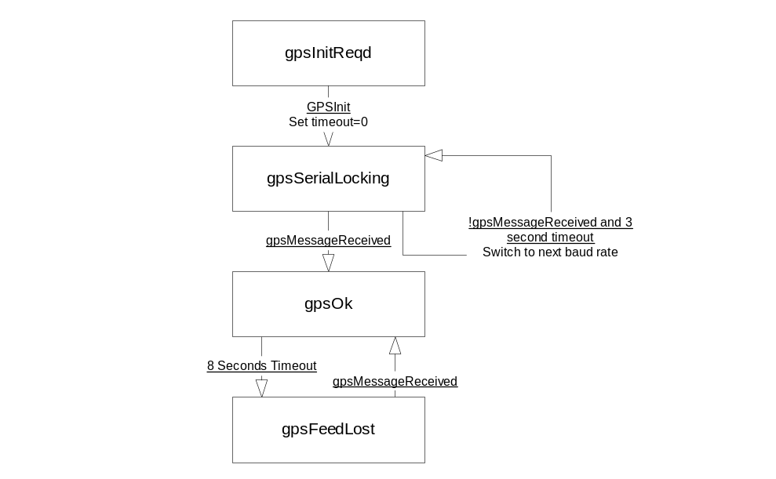
- NMEA-0183 Message Specification
NMEA Record | Description
GGA | Global positioning system fixed data
GLL | Geographic position- latitude/longitude
GSA | GNSS DOP and active satellites
GSV | GNSS satellites in view
RMC | Recommended minimum specific GNSS data
VTG | Course over ground and ground speed

GGA - Global Positioning System Fix Data
$GPGGA,<1>,<2>,<3>,<4>,<5>,<6>,<7>,<8>,<9>,M,<11>,<12>,<13><CR><LF>
1) UTC time of position fix, hhmmss.sss format
2) Latitude, ddmm.mmmm format.
3) Latitude hemisphere, N or S.
4) Longitude, dddmm.mmmm format.
5) Longitude hemisphere, E or W.
6) Position Fix Indicator, 0 = fix not available, or invalid. 1 = GPS SPS Mode, fix valid. 2 = Differential GPS, SPS Mode, fix valid. 3 = GPS PPS Mode, fix valid.
7) Number of satellites in use, 00 to 12.
8) Horizontal Dilution of Precision, 0.5 to 99.9.
9) MSL Altitude, -9999.9 to 99999.9 meters.
10) Geoidal height, -999.9 to 9999.9 meters.
11) Differential GPS (RTCM SC-104) data age, number of seconds since last valid RTCM transmission (nu1l if non- DGPS).
12) Differential Reference Station ID, 0000 to 1023. (null if non-DGPS)
13) Checksum.
GLL - Geographic Position with Latitude/Longitude
$GPGLL,<1>,<2>,<3>,<4>,<5>,<6>,<7><CR><LF>
1) Latitude, ddmm.mmmm format.
2) Latitude hemisphere, N or S.
3) Longitude, dddmT1.mmmm format.
4) Longitude hemisphere, E or W.
5) UTC time of position fix, hhmmss format.
6) Status, A = data valid or V = data not valid.
7) Checksum.
GSA - GNSS DOP and Active Satellites
$GPGSA,<1>,<2>,<3>,<3>,,,,,<3>,<3>,<3>,<4>,<5>,<6>,<7><CR><LF>
1) Mode 1, M = manual, A = automatic.
2) Mode 2, Fix type, 1 =not available, 2 = 2D, 3 = 3D.
3) PRN number, 01 to 32, of satellite used in solution, up to 12 transmitted.
4) PDOP-Position dilu1ion of precision, 0.5 to 99.9.
5) HDOP-Horizontal dilution of precision, 0.5 to 99.9.
6) VDOP-Vertical di1ution of precision, 0.5 to 99.9.
7) Checksum.
GSV - GNSS Satellites in View
$GPGSV,<1>,<2>,<3>,<4>,<5>,<6>,<7>,…<4>,<5>,<6>,<7>,<8><CR><LF>
1) Total number of GSV sentences to be transmitted, 0~3.
2) Number of message, 0~3.
3) Total number of satellites in view, 00 to 12.
4) Satellite PRN number, 01 to 32.
5) Satellite elevation, 00 to 90 degrees.
6) Satellite azimuth, 000 to 359 degrees, true.
7) Signal to noise ratio (C/No) 00 to 99 dB, null when not tracking.
8) Checksum.
NOTE:Items <4>,<5>,<6> and <7> repeat for each satellite in view to a maximum of four (4) satellites per sentence. Additiona1 satellites in view information must be sent in subsequent sentences. These fields will be null if unused.
RMC - Recommended Minimum Specific GNSS Data
$GPRMC,<1>,<2>,<3>,<4>,<5>,<6>,<7>,<8>,<9>,<10>,<11><CR><LF>
1) UTC time of position fix, hhmmss.sss format.
2) Status, A = data valid, V = data not valid.
3) Latitude, ddmm.mmmm format.
4) Latitude hemisphere, N or S.
5) Longitude, dddmmm.mmmm format.
6) Longitude hemisphere, E or W.
7) Speed over ground, 0.0 to 1851.8 knots.
8) Course over ground, 000.0 to 359.9 degrees, true.
9) Date, ddmmyy format.
10) Magnetic variation, 000.0 to 180.O.
11) Degrees 12) Checksum.
VTG - Course Over Ground and Ground Speed
$GPVTG,<1>,T,<2>,M,<3>,N,<4>,K,<5><CR><LF>
1) True course over ground, 000 to 359 degrees.
2) Magnetic course over ground, 000 to 359 degrees.
3) Speed over ground, 00.0 to 999.9 knots
4) Speed over ground, 00.0 to 1851.8 ko/hr.
5) Checksum.
PMGN - Magellan Proprietary Messages
$PMGNST,<1>,<2>,<3>,<4>,<5>,<6>,<7><CR><LF>
1) Version number
2) 1,2 or 3 for lock type (no lock, 2-d or 3-d)
3) T=True (fix) or F=False (no fix)
4) Unknown
5) Battery life in hours (00.0 to 10.0 for GPS Companion)
6) Unknown
7) PRN under consideration
- Registration Code Algorithm
The registration code unlocks functionality within MiniNav. It is based on the user’s HotSync ID.
Handango.com allows auto-generation of a registration code based on a user’s HotSync ID. If the HotSync ID is longer than 10 characters, only the first 5 and last 5 characters are used.
MiniNav uses this formula to generate the registration code based on the 10 allowed characters:
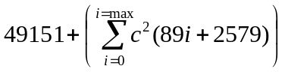
Where:
c = ascii value of character “i” in string
i = index of character (position in string, 0-based).
The result of applying the formula to a 10-character string is an Unsigned 16 bit integer (the least significant 16 bits of the result of the formula).
The corresponding RPN (Reverse Polish Notation) for use by Handango to auto-generate the key is:
i 0 = = 49151 * key + 89 i * 2579 + c c * * +

- References
1. CoPilot Database Format v4.0 (Laurie Davis)

- Code Modules
  - DbHandler Module
The DbHandler module abstracts the creation, importing, reading and writing of waypoint databases. It ensures that the main application modules do not become complicated by having to synchronise database manipulation between themselves (such as updates, record unlocking and closing etc).
  - CoPilot Interface Module
This module comprises of routines that allow MiniNav to access the data contained within CoPilot flight databases, and the CoPilot preferences. The following routines are defined:
CpIsInstalled | Returns True if the CoPilot application and correct databases are installed on this PDA, and at least one valid flight exists.
CpInitialise | Opens the CoPilot flight database – must be done prior to following calls.
CpClose | Close the CoPilot flight database
CpGetNumberOfFlights | Returns the number of flights available in the CoPilot databases, and an array of the valid flight numbers.
CpGetFlightDescription | Get the description of the specified flight number.
CpImportFlight | Convert the specified CoPilot flight into a set of MiniNav waypoints in a previously created and opened database (reference passed).
CpGetActiveFlightNum | Returns the active flight, as stored in CoPilot’s preferences.
CpGetUnitPreferences | Returns CoPilot’s unit preference settings.
CpNearestInitialiseScan | See below
CpNearestDoScan | See below
CpNearestGetAndResetChangedFlag | Part of the DB scanning process, allows another task to determine which entries in the nearest waypoint list have been modified since this function was last called. The record of changed entries is reset.
CpNearestGetWaypointByID | Given a waypoint’s ID, returns the entry number in the nearest waypoints list of that waypoint.

CoPilot Data Structures
CoPilot database structures are detailed in reference 1 (see appendix D).

Waypoint Database Scanning

CpNearestInitialiseScan
Inputs: Scan Parameters
Outputs: Pointer to nearest waypoints list
Initialise the scanning task by setting the up the search criteria according to the Scan Parameters:
- Waypoint types (VOR, VOR/DME, TACAN, NDB, Other)
- Runway Length, Width & Surfaces
Reset the current scan, if it is underway. Initialise the scan results array.

CpNearestDoScan
Inputs: Max Time (ticks), GPS Position, Emergency?
Outputs: Percent Complete
This function scans the CoPilot system and user waypoint databases, for a maximum time determined by the ticks parameter. The current GPS position is used as the basis for determining range. The function resumes scanning from the point at which it last terminated, when it reaches the end of the scan it starts over (as long as there is time left to do so).
The function filters the waypoints according to the filters set up by the last call to CpInitialiseScan.
At the start of every scan cycle, the range is updated for the waypoints in the nearest list, and the list is resorted. The function records which waypoints are in the list during this phase, because they are not re-considered during the rest of the scanning process. The update flag is then set for all the entries in the list.
Each waypoint is considered in turn. If the nearest waypoints list is full then each waypoint must pass the following tests to be accepted: (SR=search range, the range to the last waypoint in nearest waypoints list):
- Not already in the list (see above)
- Waypoint type (Airfield, navaid etc) is accepted. If the waypoint is an airfield, then check the Emergency flag – if set then the runway requirements must be met.
- Waypoint is within a lat/lon rectangle defined by SR. For longitude, the acceptable range is increased by dividing SR by cos(Lat), lat being the latitude of the GPS position.
- Waypoint actual range is < SR
If all tests pass, or the nearest waypoint list wasn’t full, then the function looks for the insertion position in the list (given the range to the waypoint) and inserts the waypoint. The function calculates the bearing to the waypoint. If inserting into a full list (i.e. the last list entry has been discarded), then update SR to the last waypoint’s range.
If a waypoint was inserted then set the update flag to show that the list entry and all those following have been modified (the Diversion Display can query & reset this flag when determining if to redraw the waypoint list or not).
The function continues to scan the databases until its alloted time has expired.

